The Velocity of Light
A Creationist and Big Bang Dilemma
The warp drive of the spaceship Enterprise in the Star Trek television series would not be possible according to the second postulate of Albert Einstein’s 1905 theory of special relativity, the constant speed of light (186,000 miles per second), since matter cannot travel faster than the speed of light. Einstein’s enshrined speed of light also poses a serious problem for young universe/earth creationists since it would take more than 10 billion years for light to travel from the most distant galaxies to Earth instead of less than the 7,000 years of Genesis.
Assuming that Einstein is correct about the speed of light, evangelical Christians have developed several approaches to solve this dilemma:
(1) Old Universe Deism in which God created the universe but natural law produced our present universe and life without the intervention of God
(2) Old Universe evolutionary theism whereby God created the universe and then gave the universe and life order over long periods of time through the process of evolution
(3) Old Universe Progressive Creationism which advocates that God created the universe and life over long periods of time but Adam and Eve and the Fall of Man are recent
(4) Young Universe with God creating light in transit from distant celestial bodies
(5) Young Universe but the speed of light has decreased dramatically over time to its present speed
(6) Old Universe with relativistic time dilation for a young earth frame of reference.
Most of the old universe and even some young earth proponents must allegorize (use of non-historical-grammatical hermeneutics/method of interpretation) most parts of Genesis 1-11, generally not holding to a literal six-day creation, a worldwide Noahic Flood nor a division of mankind by languages into races at the Tower of Babel.
The master physicist, James Clerk Maxwell, developed his famous equations of electromagnetism more than 40 years before Einstein. From these equations Maxwell derived the speed of light in an electromagnetic medium of transport:=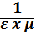, where c is the speed of light, 𝜺 is the permittivity (electric field medium parameter) and 𝝁 is the permeability (magnetic field medium parameter). The permittivity and permeability are measures of the electromagnetic field strength of the transport medium of light. All electromagnetic fields originate in the subatomic electric charges in matter. This derivation of the speed of light was an incredible achievement and has been time tested for the last 150 years. However, since (1) light travels through empty space from distant celestial bodies and (2) electromagnetic fields only come from matter, it was assumed in the late 1800s that there must be some fixed ethereal matter (aether/ether) in deep space to provide an electromagnetic medium for light to travel through from distant celestial bodies. This fixed material ether throughout the universe was considered ethereal because (1) celestial bodies could also travel through it without friction and (2) light could travel through it with negligible attenuation (loss of intensity).
In the 1880s Albert Michelson and Edward Morley conducted experiments using a light wave interferometer to determine the speed of the Earth traveling through this fixed, universal ether since there should be a Doppler effect of light (change of light speed), depending on the Earth’s speed through the fixed ether. However, there was no Doppler effect at any time or in any direction. The Earth is not traveling through any material ether which was postulated in the late 1800s as the electromagnetic medium for light transport through deep space. Einstein in his 1905 theory of special relativity stated that light (1) has a constant speed in deep space (300,000 kilometers per second) regardless of the reference frame of its origin or the frame of any observer and (2) has no medium of transport. At about the same time, Einstein developed his famous equation, E = m, which every child on Earth knows. Einstein affirmed with this equation that matter can be converted to energy and vice versa, using his constant speed of light as the conversion factor. Presently, astronomical distances are measured in terms of light-years, the time it takes for light to travel at Einstein’s constant speed in one year, instead of kilometers or miles (one light year = 9 x kilometers). Einstein’s ideas about the nature and speed of light are the sacrosanct centerpieces of modern relativity, including general relativity, the macrocosm of modern physics.
Our understanding of the nature of matter is presently clearer than when Einstein affirmed his medium-less, constant speed of light theory in 1905. Matter is composed of subatomic electric charges (electrons, protons, neutrons). The electromagnetic fields of these subatomic charges extend into infinity, supplying an electromagnetic medium for light to travel through the universe, howbeit weak in deep space. Maxwell’s derivation of the speed of light states that the speed of light is inversely proportional to the electromagnetic strength of light’s transport medium. As the electromagnetic field strength increases (higher permittivity and permeability), then the speed of light will decrease. For instance, in diamonds, nature’s strongest material, the electromagnetic strength is strong so that the speed of light decreases to one half of its speed in air or a vacuum. On the contrary, as the electromagnetic field strength decreases, as would happen in deep space where the electromagnetic fields of the subatomic electric charges in the matter of celestial bodies become very weak, then the speed of light will increase according to Maxwell’s derivation. Although there is no place in the Universe where the electromagnetic field strength (the product of permittivity and permeability in the denominator of Maxwell’s equation) becomes zero, these electromagnetic parameters (permittivity and permeability) will approach zero and the speed of light will approach infinity in interstellar and intergalactic space.
Not only has Maxwell’s derivation experimentally withstood the test of time without exception here on the Earth, two phenomena also indicate that Maxwell’s derivation is true in the vacuum of space far from Earth. Two space probes, Pioneer 10 & 11, were sent on a tour of the planets in our solar system beyond Pluto into deep space. Until contact was lost in about 2003, the position of Pioneer 10 was determined from radio transmission times assuming Einstein’s constant speed of light and compared to its position from a Newtonian gravitational calculation. Over time the probe appeared to be closer according to the signal transmission than the Newtonian positions and the error became greater with the passage of time and the distance from the center of our solar system. Since the subatomic electromagnetic fields from the matter in our solar system became weaker as Pioneer 10 moved farther into deep space, then the speed of the signal (speed of light) will increase according to Maxwell’s speed of light derivation. The lapsed time of the transmission signal from the Earth to the probe and back again will take less time to travel and the probe’s position determined using Einstein’s constant speed would appear to be closer than it really is. This effect happens and is known as the Pioneer Anomaly.
Inversely, the speed of light in space will decrease as light approaches the center of the electric charge of a celestial system. In the 1960s, Irwin Shapiro bounced x-rays (traveling at the speed of light) off of the planets of Mercury and Venus which are to the inside of Earth’s orbit and closer to the electromagnetic center of our solar system. In Shapiro’s experiment the x-rays traveled in the vacuum of space slower than the Einstein’s constant light speed and the result of this experiment is called the Shapiro Delay Effect. Some physicists would attribute this effect to general relativity, but that assumption is wrong, as also in the case of the Pioneer Anomaly, because a gravity Doppler effect (change of light speed) will not happen for a signal coming and going to the same gravitational equipotential (same gravitational strength) location (the Earth’s surface in both the Pioneer and Shapiro cases).
The implications of this Maxwellian speed of light are interesting:
(1) Scotty, the principal engineer on the Star Trek Enterprise space ship, really could have a warp drive as multiples of Einstein’s light speed in interstellar space. In fact, with the right propulsion system we could visit the most distant galaxies in just a few years traveling at nearly infinite speeds but less than the Maxwellian speed of light in deep intergalactic space.
(2) Adam and Eve could probably have seen all of the 7,000 celestial bodies visible to the naked eye on the sixth day of Creation.
(3) In accordance with Maxwell’s equation, we can see today the most distant galaxies with our most powerful telescopes. Maxwellian light could travel from the most distant galaxies in only a few years, much less than 7,000 years.
(4) The biblical account of Creation in six days of twenty-four hours each could easily have taken place less than 7,000 years ago as an historical-grammatical hermeneutic of Genesis 1-11 indicates.

Light from Distant Galaxies:
New or Ancient Light? Maxwell or Einstein? New or Old Universe?
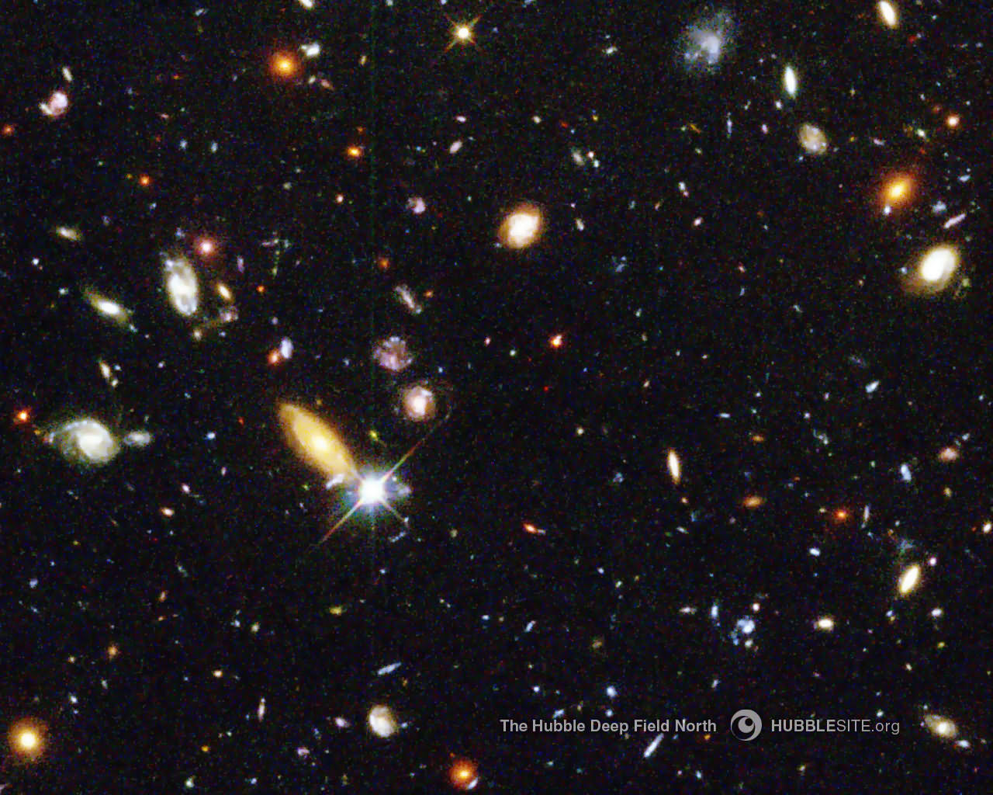

Below is a photo taken in one trillionth of a second of a light wave from a laser traveling in a Coke bottle of water from the bottom to the top of the bottle. This photo is possible in water because a light wave illuminates the surrounding water molecules as it travels through the bottle, losing its energy but allowing the light path to be seen in the photo. Light waves traveling down in clear ocean water lose enough energy so that there is total darkness at less than 3,000 feet of water depth even from the sunlight at the equator. This photo below would not be possible in deep space because there is almost no loss of light wave energy even traveling over trillions of trillions of miles of deep space.

Photo (${10}^{-9}$ Seconds) of Light Wave Traveling in Coke Bottle

